Maths for Understanding Warp Drives

Numbers and Complex Numbers (see complex numbers file)

Vectors

Matrices

Tensors
(source: Science Asylum (2020) “What's a Tensor?”, https://www.youtube.com/watch?v=bpG3gqDM80w, accessed 6/15/22)

A rank-n tensor in m-dimensions is a mathematical object that has n indices and m-to-the-n components that obeys certain transformation rules.

The word "tensor" actually comes from an old Latin word meaning "to stretch."If you pull an object outward along its length, it experiences something called "tensile stress."
In response, it’s length increases. that’s not the only type of stress an object can experience.
This cube could be stretched or compressed along any of the 3 spatial directions.

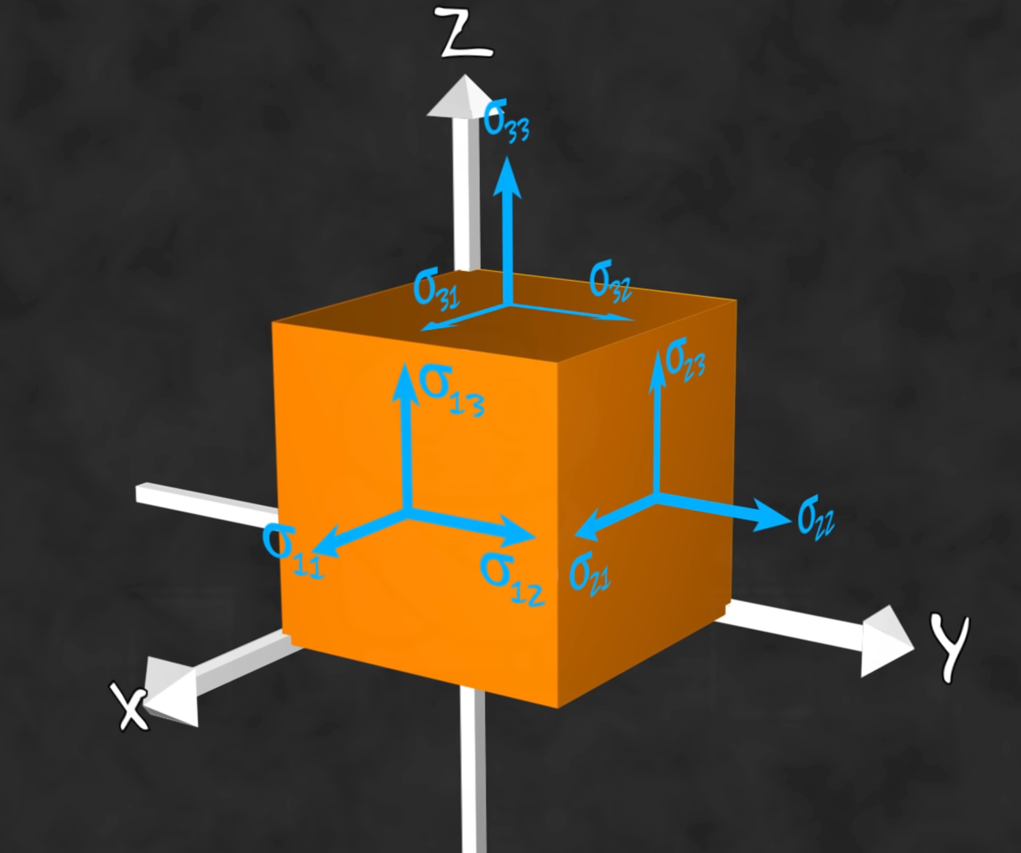
Wouldn’t a vector be enough for that? First, a vector is a tensor and, second, there are 6 other stresses I haven’t mentioned yet. The cube could also be sheared along those directions. That’s 9 possible stresses. Each of these forces makes the cube respond in a different way.
We have to consider them all separately.

These 9 different stresses are usually organized into a 3-by-3 matrix called the stress tensor.
Quick Disclaimer: It’s not a tensor because I can write it as a matrix.
Matrices and tensors are not the same thing. A matrix is just a convenient way to organize numbers

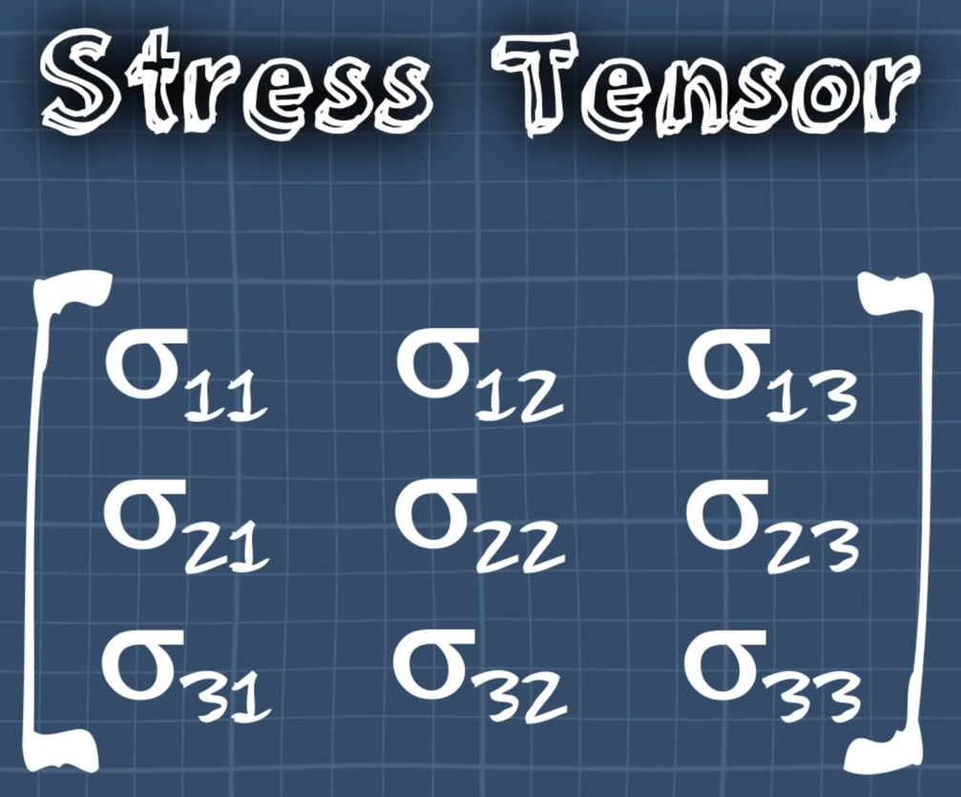
.

Writing the stress tensor like this, we can see it clearly has 9 components,
but our definition mentioned two specific properties: Rank and Dimension. This cube is 3-dimensional, so any tensor describing it’s behavior will also be dimension-3. That’s why our stress tensor is organized into 3 rows and 3 columns. Each corresponds to a specific direction in 3-dimensional space. Rank is the amount of information you need to find a specific component. In this case, we only need a row and a column. That’s 2 pieces of information, so we say the tensor is rank-2. The stress tensor is rank-2 and dimension-3. Matrix notation is really convenient for rank-2 tensors of any dimension.
With the electromagnetic field tensor, you still only need a row and column to find a component, so it’s rank-2.

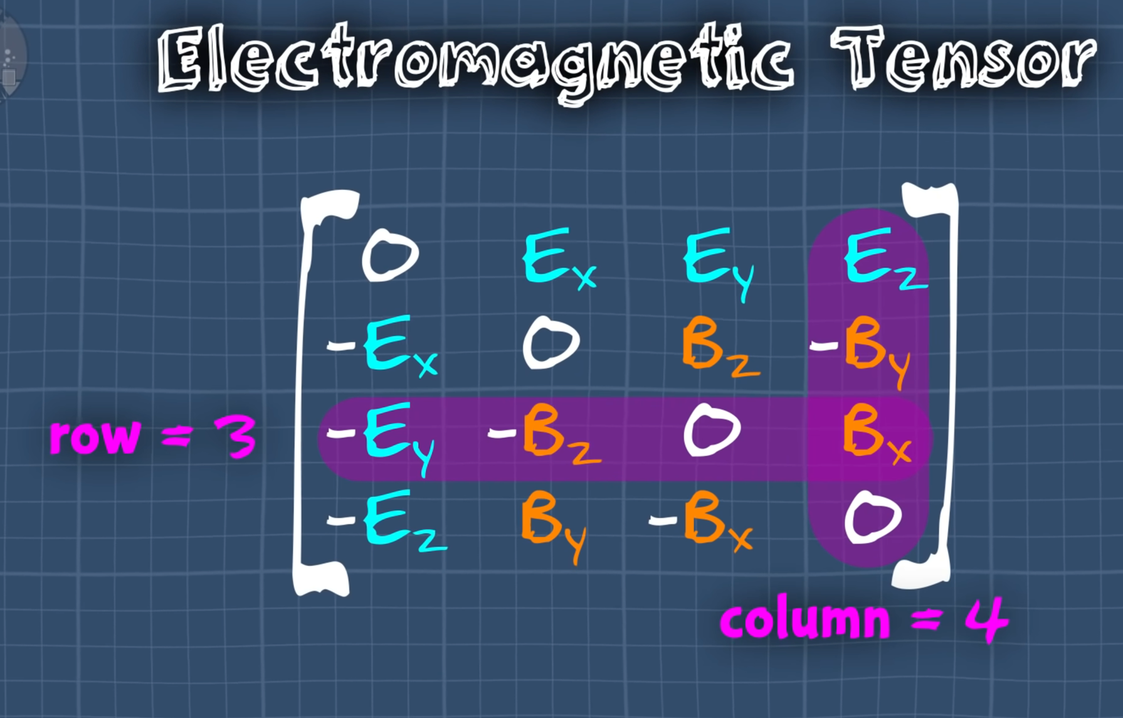

However, there 4 rows and 4 columns, which means this tensor is 4-dimensional. The electromagnetic field tensor (F_{μν}) is rank-2 and dimension-4.
This notation starts to fall apart with higher rank tensors though. For example, a rank-3 tensor requires 3 pieces of information to find a component.
While this is still technically a matrix, the math operations aren’t very obvious. It gets even worse with rank-4 tensors.

Index notation! Rank-zero means you don’t need any information to find a component. That’s just a scalar, T. Rank-1 means we only need one piece of information to find a component, Ti. In other words, we only need one index. That’s just a vector. Rank-2 means we need two pieces of information or 2 indices, Tij. Traditionally, we use Latin letters for 2 and 3 dimensions and Greek letters for 4 dimensions, which helps make rank and dimension more obvious at a glance. Rank-3 means 3 indices Tijk, rank-4 means 4 indices, Tijkl, and so on.
Definitively a tansor is unique by how they transform. The key to transformation is that we are trnasforing a coordinate system. To use physics on this scenario, we need to assign a coordinate system to it.Shifting to a steadily moving coordinate system is something we call a boost and it requires we include time as an additional axis. A ball may be moving through space, but it’s also moving through time. It has its own time axis. We call this spacetime and a boost is a just a 4-dimenional coordinate rotation. But, if we want to talk about velocity, we need a 4-dimensional velocity or 4-velocity, which is a rank-1 dimension-4 tensor. You can’t work in 4-dimensions without using 4-dimensional tensors.
Unfortunately, a rank-2 tensor can’t be visualized as an arrow like a vector can, but it can be understood as a transformation between vectors.

In fact, that’s exactly what this equation says about the EM tensor. It transforms the 4-velocity of a charged particle into a force. A moving charged particle inside of a force field experiences a force.

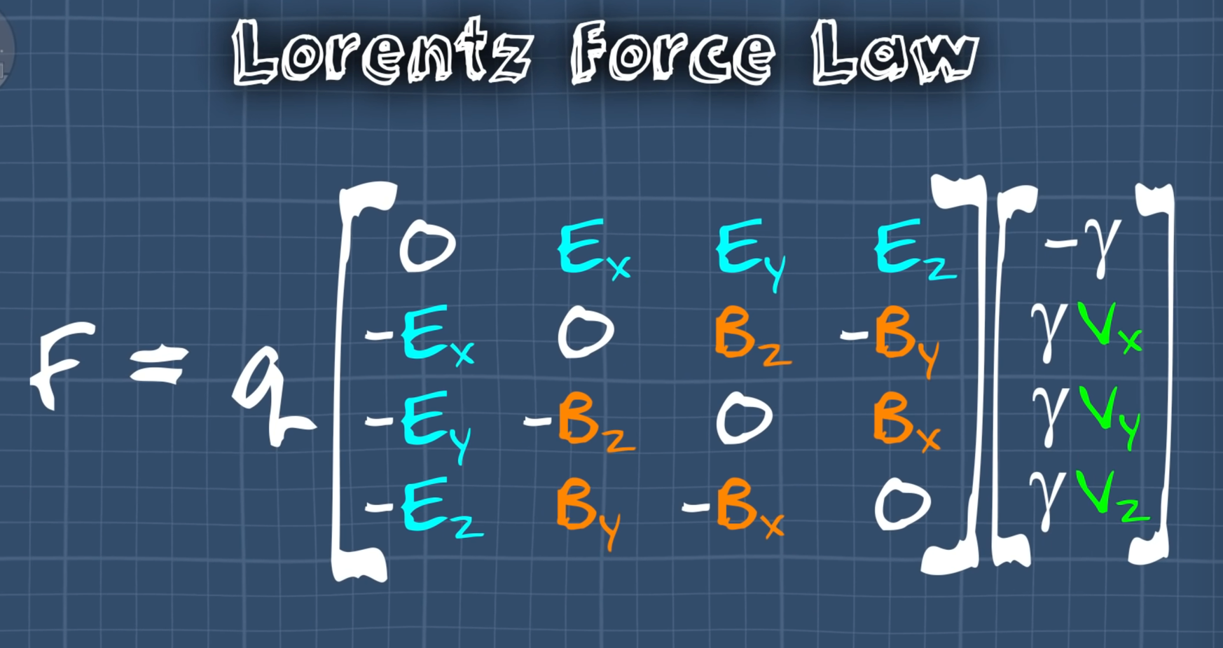

So what’s a tensor? It’s a number or collection of similar numbers that maintains its meaning under transformations.

If you make a different choice in coordinates, the components of the tensor will change, but in a way that conspires to keep the meaning of the tensor the same. This velocity vector is a rank-1 tensor that describes the motion of the ball, regardless of the coordinate choice.
This stress tensor is a rank-2 tensor and describes how to get a force from area,
regardless of the coordinate choice. If your number or collection of numbers doesn’t do that, then it’s not a tensor.

General Relativity by Brian Green

https://www.youtube.com/watch?v=2cO8Qq-fthQ

Physicist Albert Einstein's theory of General Relativity is about how gravity affects the grid of space-time. First, published in 1915, it was an expansion on special relativity from 1905. Special relativity argued that space and time are inextricably connected, but it lacked an accounting of gravity, which is to say curvature.

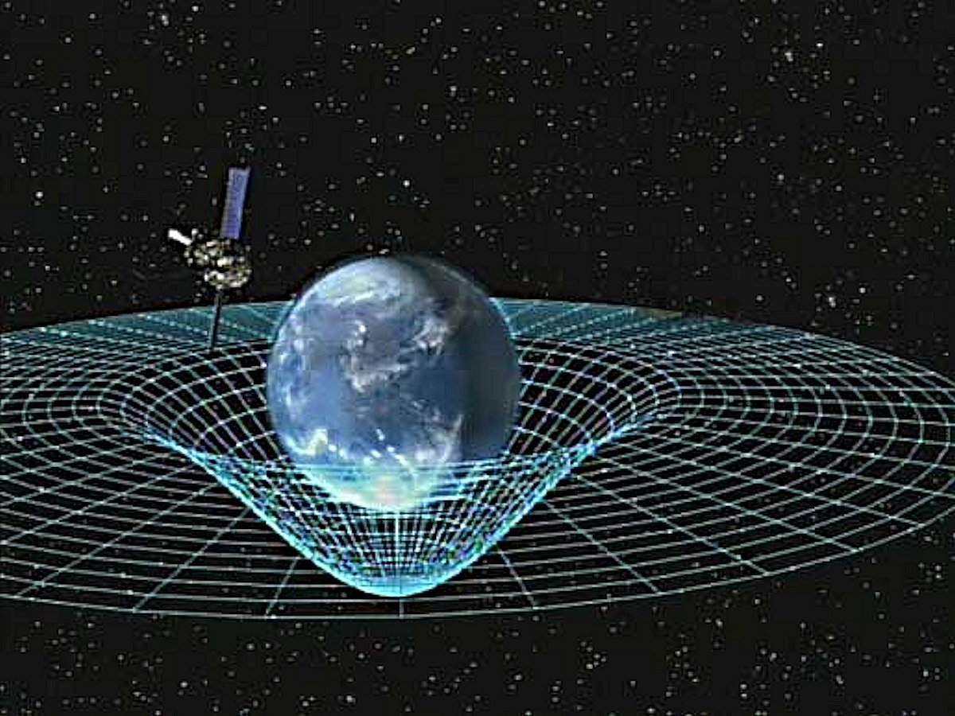

image credit: https://en.wikipedia.org/wiki/Curved_space#/media/File:GPB_circling_earth.jpg
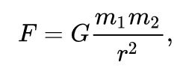

Newton's universal law of gravity: that if you have two masses, mass m1 and mass m2, that there is a universal force of attraction between them acting to pull them together and the formula for that is a constant Newton's gravitational constant M 1 M 2 divided by the square of their separation, so if their distance r apart then you divide by r squared and the direction of the force is along the line connecting their center. This worked till Einstein came along.
Einstein begins to think about the force of gravity in 1907, he comes to the conclusion that
Newton's law that he gave us can't really be the full story. Einstein reasoned by noting that in
this formula that Newton gave us there's no time variable, there's no temporal
quality to that law. Why do we care about that? Think about it, if I was to change the value of the mass then according to this formula the force would immediately change, so the force
felt over here at mass M - given by this formula will immediately change if say I
change the value of M 1 in this equation or if I change the separation if I move
M one this way making our a little smaller or this way making our a little bit bigger to immediately feel the effect of that change instantaneously, faster than the speed of light and
Einstein says maybe I would be able to calculate the speed of that influence, I will be able to show that in Newton's theory the force of gravity is not instantaneous so Einstein goes to
check in on this and and he realizes Newton himself realized that he had never specified the mechanism by which gravity exerts influence he said look if you have the Sun and you have the earth and they're separated by a distance there is a force of gravity between them and it gives us a formula for it but it doesn't tell us how gravity actually exerts that influence and therefore there is no mechanism that Einstein could analyze to truly figure out the speed with which that mechanism for transmitting gravity operates and therefore he was stuck.
Einstein sets himself the goal of truly figuring out the mechanism of how gravitational
influences are exerted from place to place and he starts at about 1907 and finally by 1915 he writes down the final answer in the form of the equations of the general theory of relativity and the basic idea. Einstein says look if say you have the Sun and the earth and the Sun
is exerting an influence on the earth what could be the source of that influence? The puzzle is there's nothing but empty space between the Sun and the earth, if there's only empty
space then it must be space itself that communicates the influence of gravity. Einstein ultimately comes the realization that space and time can warp and curve and through the curved shape influences the motion of objects in space.
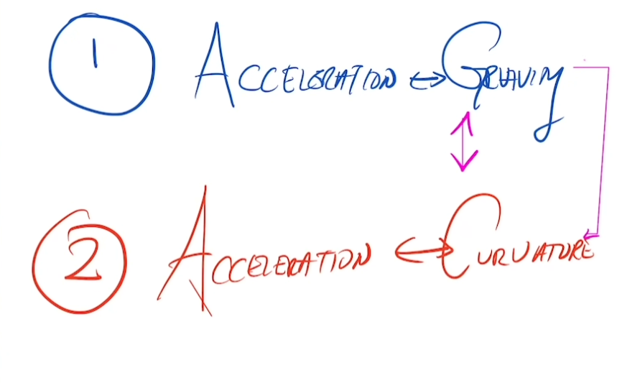

It influences in a two-step process: 1. Einstein realizes that there is
a deep and unexpected connection between accelerated motion, acceleration and
gravity; 2. there is another unexpected relationship between acceleration and curvature curvy space times curvature and then of course he realizes that there is a connection therefore between gravity and curvature, so this link is forged through acceleration being the common quality that leads you both to an understanding of gravity and understanding of curvature. Therefore, a link between gravity and curvature.
Einstein saw the link in what he calls the happiest thought of his entire life. What is that happiest thought? He imagines a painter who is painting the exterior of a building on a hind ladder he matches that painter falling off the ladder falling off the roof and going into freefall,
the painter during this descent will not feel their own weight, like at the precipice of a swing, you go weightless as the swing reverses course momentarily. Imagine that the painter is standing on a scale, as the painter falls the scale falls at the same rate as the painter therefore they fall together, meaning the painters feet don't exert a push on the scale, they can't because the scale is moving away at exactly the same rate as the feet are moving downward too so looking down at the reading on the scale that painter will see that the reading drops to zero, the painter feels weightless. Accelerated downward motion can in some sense cancel out the force of gravity, accelerated motion can not only cancel out gravity but accelerated motion can mimic gravity, sort of a fake version of gravity, like when taking off in an airplane.
An observer in an accelerated frame of reference say on a circular ride, imagine that you measure the circumference of this ride from the outside, not on the ride itself, so you lay out these rulers and say it is 10m, you can also measure the radius and you can get a number for that as well and indeed if you look at the relationship between the circumference and the radius you will find that circumference equals 2pi times r.

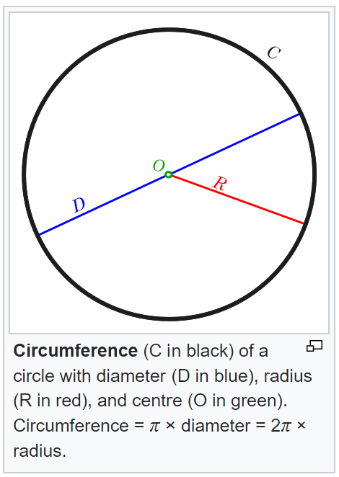
Now imagine measuring this from the perspective of someone on the ride itself, the accelerated observer, well when they measured the radius they're going to get the exact same answer because that's moving perpendicular to the motion, no Lorentz contraction, but if you measure the circumference look what happens the rulers are all instantaneously moving in the direction of the motion so that you're shrunken and contracted. Therefore, the circumference is longer. more of those rulers to go all the way around in this particular case I just imagine that it's 11m, radius is unchanged again that's moving perpendicular to the instantaneous direction of the motion which is all in the circumferential direction right radius is going this way circumference is going that way, so there's no change in the measurement of the radius which means circumference will no longer equal to 2pi times r. In the first measurement these were circles that were drawn on a flat surface it must therefore be the case that from the perspective of the person on the ride taking the measurement and feeling that gravitational force accelerating that feel that force pulling them outward from their perspective it must be that circle is not flat, must be curved, it accelerated motion from the circle gives rise to the feeling of a gravitational like force that accelerated motion gives rise to measurements from the perspective of the person experiencing that acceleration that do not satisfy the usual rules of flat Euclidean so-called geometry and therefore we learned that there is a connection between gravity and curvature.

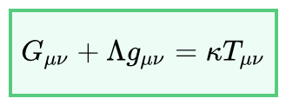
where G_{μν} is the Einstein tensor, g_{μν} is the metric tensor, T_{μν} is the stress–energy tensor, Λ is the cosmological constant and κ is the Einstein gravitational constant.

The Einstein tensor is defined as
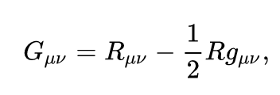

where R_{μν} is the Ricci curvature tensor, and R is the scalar curvature. This is a symmetric second-degree tensor that depends on only the metric tensor and its first and second derivatives.
The Einstein gravitational constant is defined as
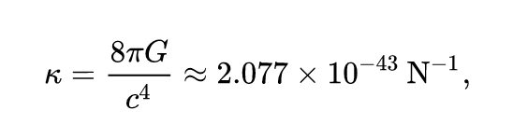
where G is the Newtonian constant of gravitation and c is the speed of light in vacuum.
The EFE can thus also be written as
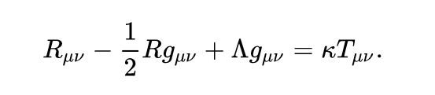
In standard units, each term on the left has units of 1/length².

The expression on the left represents the curvature of spacetime as determined by the metric; the expression on the right represents the stress–energy–momentum content of spacetime. The EFE can then be interpreted as a set of equations dictating how stress–energy–momentum determines the curvature of spacetime.

These equations, together with the geodesic equation (see below) which dictates how freely falling matter moves through spacetime, form the core of the mathematical formulation of general relativity.

The EFE is a tensor equation relating a set of symmetric 4 × 4 tensors. Each tensor has 10 independent components. The four Bianchi identities reduce the number of independent equations from 10 to 6, leaving the metric with four gauge-fixing degrees of freedom, which correspond to the freedom to choose a coordinate system.

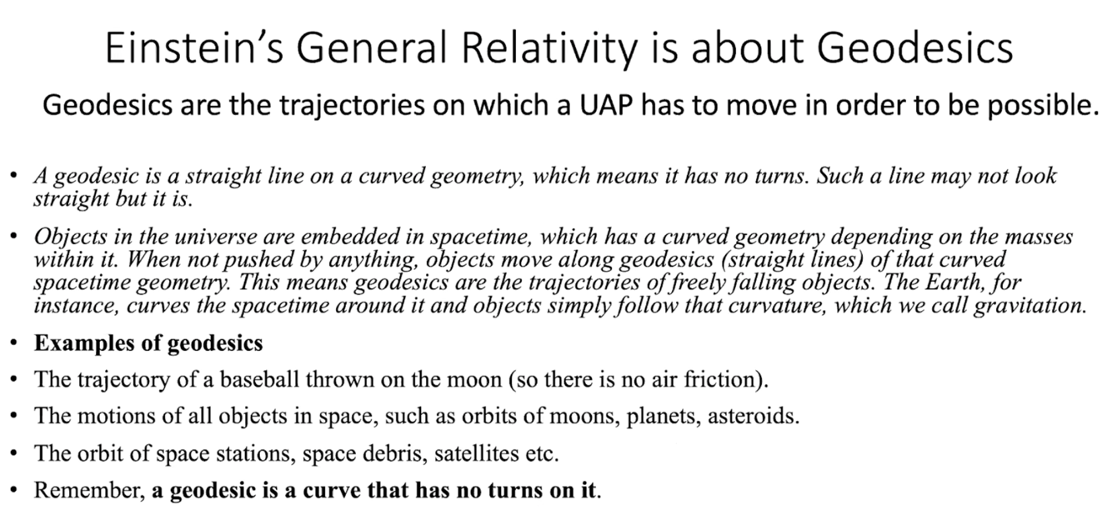
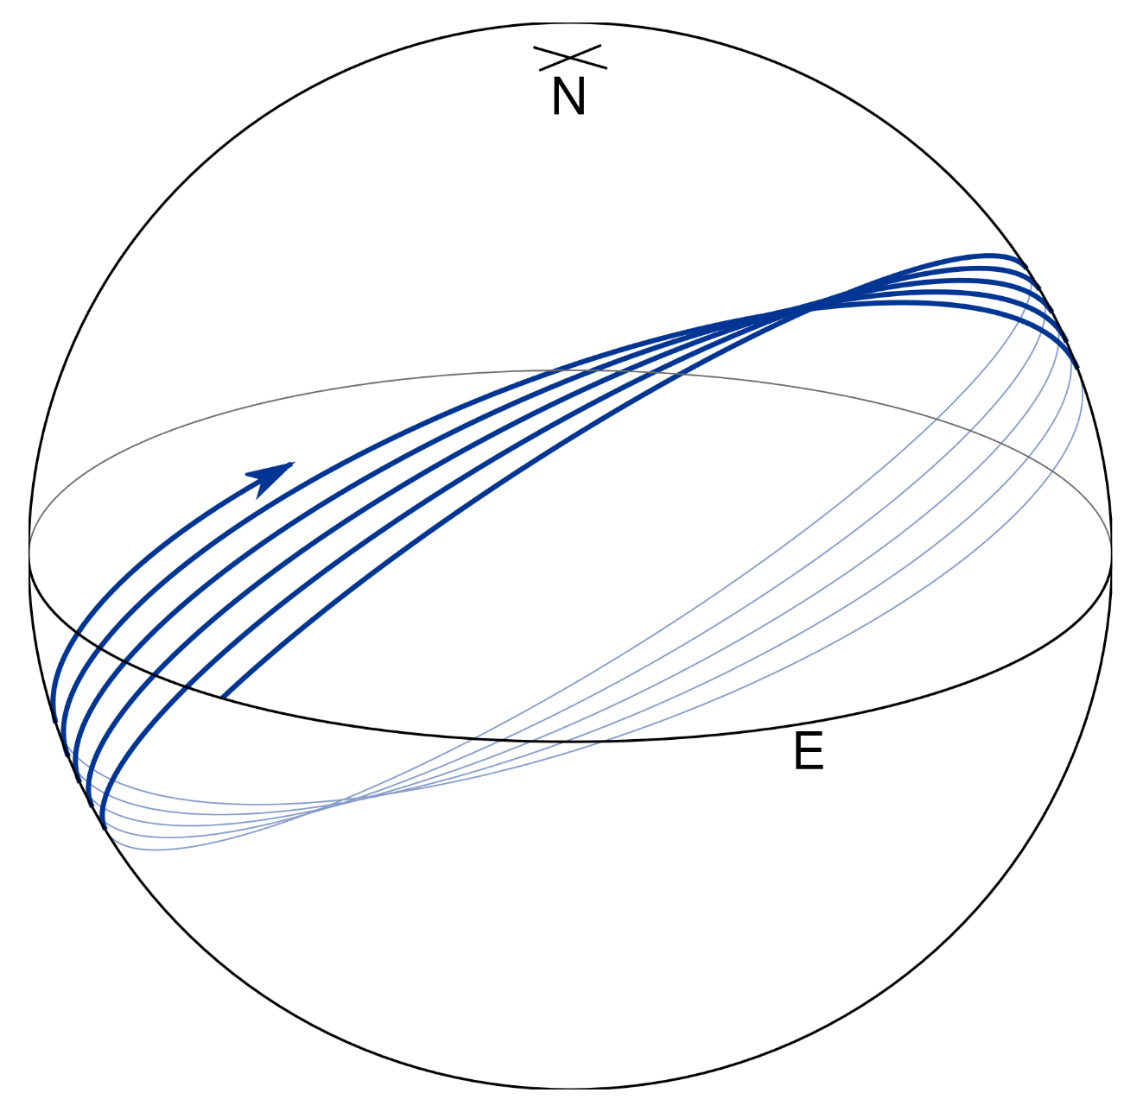

Image credit: https://upload.wikimedia.org/wikipedia/commons/7/77/Long_geodesic_on_an_oblate_ellipsoid.svg

Geodesic Equation
In general relativity, a geodesic generalizes the notion of a "straight line" to curved spacetime. Importantly, the world line of a particle free from all external, non-gravitational forces is a particular type of geodesic. In other words, a freely moving or falling particle always moves along a geodesic.

In general relativity, gravity can be regarded as not a force but a consequence of a curved spacetime geometry where the source of curvature is the stress–energy tensor (representing matter, for instance). Thus, for example, the path of a planet orbiting a star is the projection of a geodesic of the curved four-dimensional (4-D) spacetime geometry around the star onto three-dimensional (3-D) space.

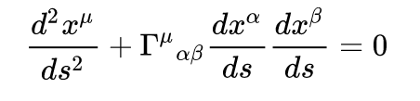
where s is a scalar parameter of motion (e.g. the proper time), and Γ^{μ}_{αβ} are Christoffel symbols (sometimes called the affine connection coefficients or Levi-Civita connection coefficients) symmetric in the two lower indices. Greek indices may take the values: 0, 1, 2, 3 and the summation convention is used for repeated indices α and β. The quantity on the left-hand-side of this equation is the acceleration of a particle, so this equation is analogous to Newton's laws of motion, which likewise provide formulae for the acceleration of a particle. The Christoffel symbols are functions of the four spacetime coordinates and so are independent of the velocity or acceleration or other characteristics of a test particle whose motion is described by the geodesic equation.

